#include <iostream>
#include<bitset>
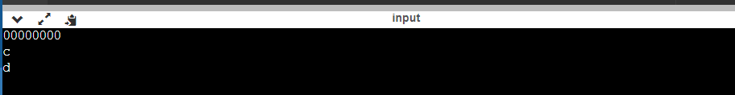
using namespace std;
int main()
{
char a ='b';
char b ='c';
char c='d';
int d=2;
a<<=a>>d^c;
b>>=a&~c;
cout<<bitset<8>(a)<<endl;
cout<<b<<endl;
cout<<c<<endl;
}
Solution:

